
QualifyHub

Technological Entrepreneurship Business Project
Instructor: Aitolkin Sagynbayeva
Team Members: Amir Kurmanbekov, Ali Parwiz B, Rasul Turtolov
Creating your Value propositions as part of Business model Canvas

1. Introduction
A business model describes how a company creates, delivers, and captures value in a specific market. It explains what product or service is offered, how it is marketed, which costs it incurs, and how it ultimately turns a profit. For technology ventures, essential elements of a robust business model include a clear value proposition, a well‑defined target market, and a sustainable competitive advantage. If any of these components is weak or missing, the business struggles to generate predictable revenue and cannot scale.
Kazakhstan’s IT sector provides a strong context for testing new technology‑driven business models. By the end of 2024, the number of IT companies in Kazakhstan reached 18,683, which represents about a 16% increase over three years, and approximately 187,000 people worked in the IT sector, 12% more than three years earlier. In the same period, the average monthly salary of IT specialists rose by 54%, reaching around 673,000 tenge, reflecting high demand for technical talent and competitive working conditions. These figures show that digital transformation is not only a political priority but also a rapidly expanding labor market with growing pressure on recruitment processes.​
However, this growth has also created structural challenges in hiring. Research by Ranking.kz and national labor exchange data show that in 2025 there were about 9,700 resumes in the “IT and telecommunications” category but only 580 vacancies, which means nearly 17 applicants for each IT position nationwide. In some regions the situation is more extreme: Mangystau region reported 655 resumes competing for just 4 vacancies (≈164 per vacancy), while Almaty and Astana had around 11 and 8 candidates per vacancy respectively. Employers must therefore screen many candidates, while developers struggle to differentiate themselves in a crowded market.​
QualifyHub is a proposed platform that tackles these inefficiencies in Kazakhstan’s technical recruitment. The platform offers human‑verified technical assessments and reusable Verified Talent Profiles that developers can share with multiple employers. Employers gain access to a curated pool of evaluated candidates and analytics on hiring efficiency, which reduces interview load and time‑to‑hire. The following sections present the chosen business model category, customer segments and relationships, quantitative market evidence, and a structured Value Proposition Canvas for QualifyHub.

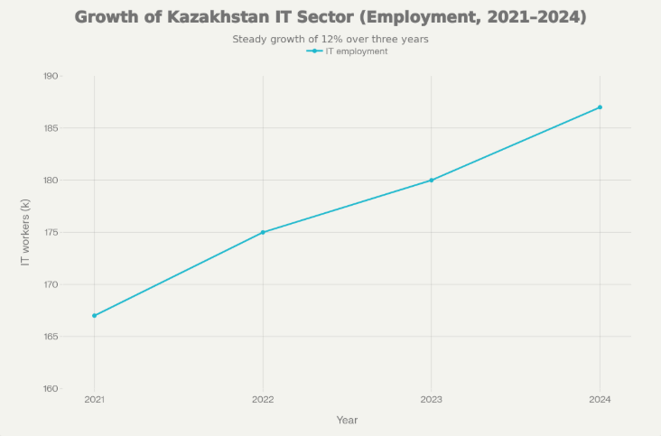
Figure 1. Growth of Kazakhstan IT sector employment, 2021–2024 (illustrative, based on national IT statistics)

2. Step 1 – Business model category and justification

2.1 Selected category: B2B with supporting B2C
QualifyHub operates primarily as a B2B (Business to Business) platform, complemented by a supporting B2C dimension. The core paying customers are organizations that hire technical talent, such as IT companies, fintech firms, banks, and startups. These organizations subscribe to QualifyHub or pay per candidate to access a pool of pre‑vetted developers and to use assessment and analytics tools in their recruitment processes. Developers participate on the platform as a secondary, mostly non‑paying side, by completing assessments and maintaining Verified Talent Profiles that increase their visibility and employability.
This configuration reflects the reality of who experiences the strongest pain and who is most willing to pay. Employers face quantifiable burdens: high screening volumes, long time‑to‑hire, and the risk of poor hiring decisions that can cost about 30% of an employee’s annual salary in similar markets. They are therefore motivated to pay for solutions that reduce complexity and risk. Developers face important but less directly monetizable pains (repetitive tests, difficulty standing out), so they benefit more as value receivers than as primary payers.​

2.2 Value creators and value receivers
In the QualifyHub ecosystem, multiple actors create and receive value:
- Value creators
  - QualifyHub, which provides the platform, assessment technology, and analytics.
  - Technical experts (senior developers, tech leads) who design and conduct assessments.
  - Developers, who contribute their skills, code, and portfolios to form the Verified Talent Profiles.
- Value receivers
  - Employers, who receive access to a curated pool of evaluated candidates, plus analytics and tools to streamline hiring.
  - Developers, who receive a recognized verification of skills, higher visibility to employers, and structured feedback.
This multi‑sided structure enhances network effects: as more developers join and complete assessments, QualifyHub becomes more valuable to employers, and as more employers use the platform, it becomes more attractive for developers.

2.3 Value and money flows
The flows of value and money can be summarized as follows:
- Value flows
  - Developers QualifyHub: time and effort invested in assessments, plus portfolio and skills data.
  - Experts QualifyHub: assessment design and evaluation expertise.
  - QualifyHub Employers: access to Verified Talent Profiles, search tools, and performance analytics.
  - QualifyHub Developers: Verified Talent Profiles, personalized feedback, and access to hiring opportunities.
- Money flows
  - Employers QualifyHub: subscription fees for ongoing access, per‑candidate fees for occasional use, and premium enterprise contracts for advanced analytics or integrations.
  - QualifyHub Experts: compensation for conducting assessments and maintaining rubrics.
  - Developers: mostly use the platform for free or at low cost; some may pay for optional extras such as advanced assessments or career coaching.
This configuration clearly demonstrates a B2B revenue model, with developers contributing data and attention rather than being the main revenue source.

2.4 Why alternative models are less suitable
- Pure B2C
A pure B2C model would require developers to pay for access and assessments. Given that many IT job seekers in Kazakhstan are junior (around 48% of job seekers are entry‑level) and may have limited resources, relying on them as the primary revenue source would be risky. Moreover, the main measurable cost savings (time‑to‑hire, reduced interview load) occur on the employer side, which strengthens the logic for B2B rather than B2C.​
- C2B (Consumer to Business)
C2B models typically involve consumers selling value (e.g., content or data) directly to businesses for payment. In QualifyHub, developers are not selling services directly to employers through the platform; instead, the platform organizes assessment and then sells a recruitment solution to companies. That structure is better understood as B2B with a multi‑sided platform.
- C2C (Consumer to Consumer)
C2C would mean developers transacting primarily with other individuals, which does not address the central pain points in corporate hiring. Employers need standardized, trustworthy assessments and tools to support organizational decision‑making, not a peer‑to‑peer marketplace.
Because of these reasons, B2B with a strong B2C support side is the best fit for QualifyHub’s value and money flows.

3. Step 2 – Customer segments and customer relationships

3.1 Customer segments

3.1.1 Primary customer segment: Employers
Definition and characteristics
The primary customers are mid‑sized and large organizations (20–500+ employees) that regularly hire software developers and related roles. This group includes:
- IT services and product companies.
- Fintech firms and digital banks.
- Corporate IT departments in major enterprises and banks.
- Tech startups and scale‑ups, particularly those affiliated with Astana Hub and other regional innovation hubs.​
By the end of 2024, Kazakhstan had 18,683 IT companies, and Astana Hub alone hosted more than 1,700 resident companies whose combined revenue reached about KZT 1.2 trillion. Around 187,000 people were employed in the IT sector, indicating a sizeable and dynamic ecosystem of organizations that need reliable recruitment solutions.​
Behavior and pain points
Employers in this segment face:
- High screening volumes due to competition: about 9,700 IT/telecom resumes versus 580 vacancies nationally, corresponding to approximately 17 applicants per vacancy.​
- Regional imbalances in supply and demand, such as Mangystau’s 164 resumes per vacancy, which make it hard to efficiently process applications and identify suitable candidates.​
- A strong preference for mid‑level professionals: approximately 61% of IT vacancies require 1–5 years of experience, and only 31% are suitable for juniors, despite a large junior applicant pool.​
These characteristics make employers ideal B2B customers: they experience significant cost and risk in hiring, have ongoing recruitment needs, and are willing to pay for tools that address these specific problems.
Reasoning for selection
The primary segment was selected because it:
- Has clear, measurable pain in the current hiring process (time, cost, risk).
- Controls budgets that can be allocated to HR tech and recruitment optimization.
- Operates in a growing market (IT and digitalization) where hiring is constant and strategic.

3.1.2 Secondary segment: Developers
Definition and characteristics
The secondary segment consists of developers aged roughly 20–40, spanning junior, mid‑level, and senior experience levels. This includes:
- Graduates from universities such as Nazarbayev University, KBTU, and Satbayev University.
- Graduates of private IT schools and bootcamps under the Tech Orda initiative, which aims to train around 20,000 specialists by 2025.​
- Self‑taught developers and career switchers.
Surveys show that the median IT specialist in Kazakhstan is about 26 years old, with 3–5 years of experience, often working in fintech and earning around 700,000 tenge per month. At the same time, 48% of IT job seekers are entry‑level and 22.9% are senior, indicating a skewed distribution at both ends of the experience spectrum.​
Behavior and needs
Developers are active on LinkedIn, GitHub, hh.kz, and local Telegram and Discord communities. They are competing in a market where there can be double‑digit numbers of candidates per vacancy in major cities and much higher ratios in certain regions. Many want ways to stand out beyond their CVs and to avoid repeating similar technical tests for each company.​
Reasoning for selection
Developers are essential for platform liquidity, as their profiles and assessments form the product that employers pay to access. They benefit from improved signaling and reduced interview repetition, even though they are not the primary revenue source.

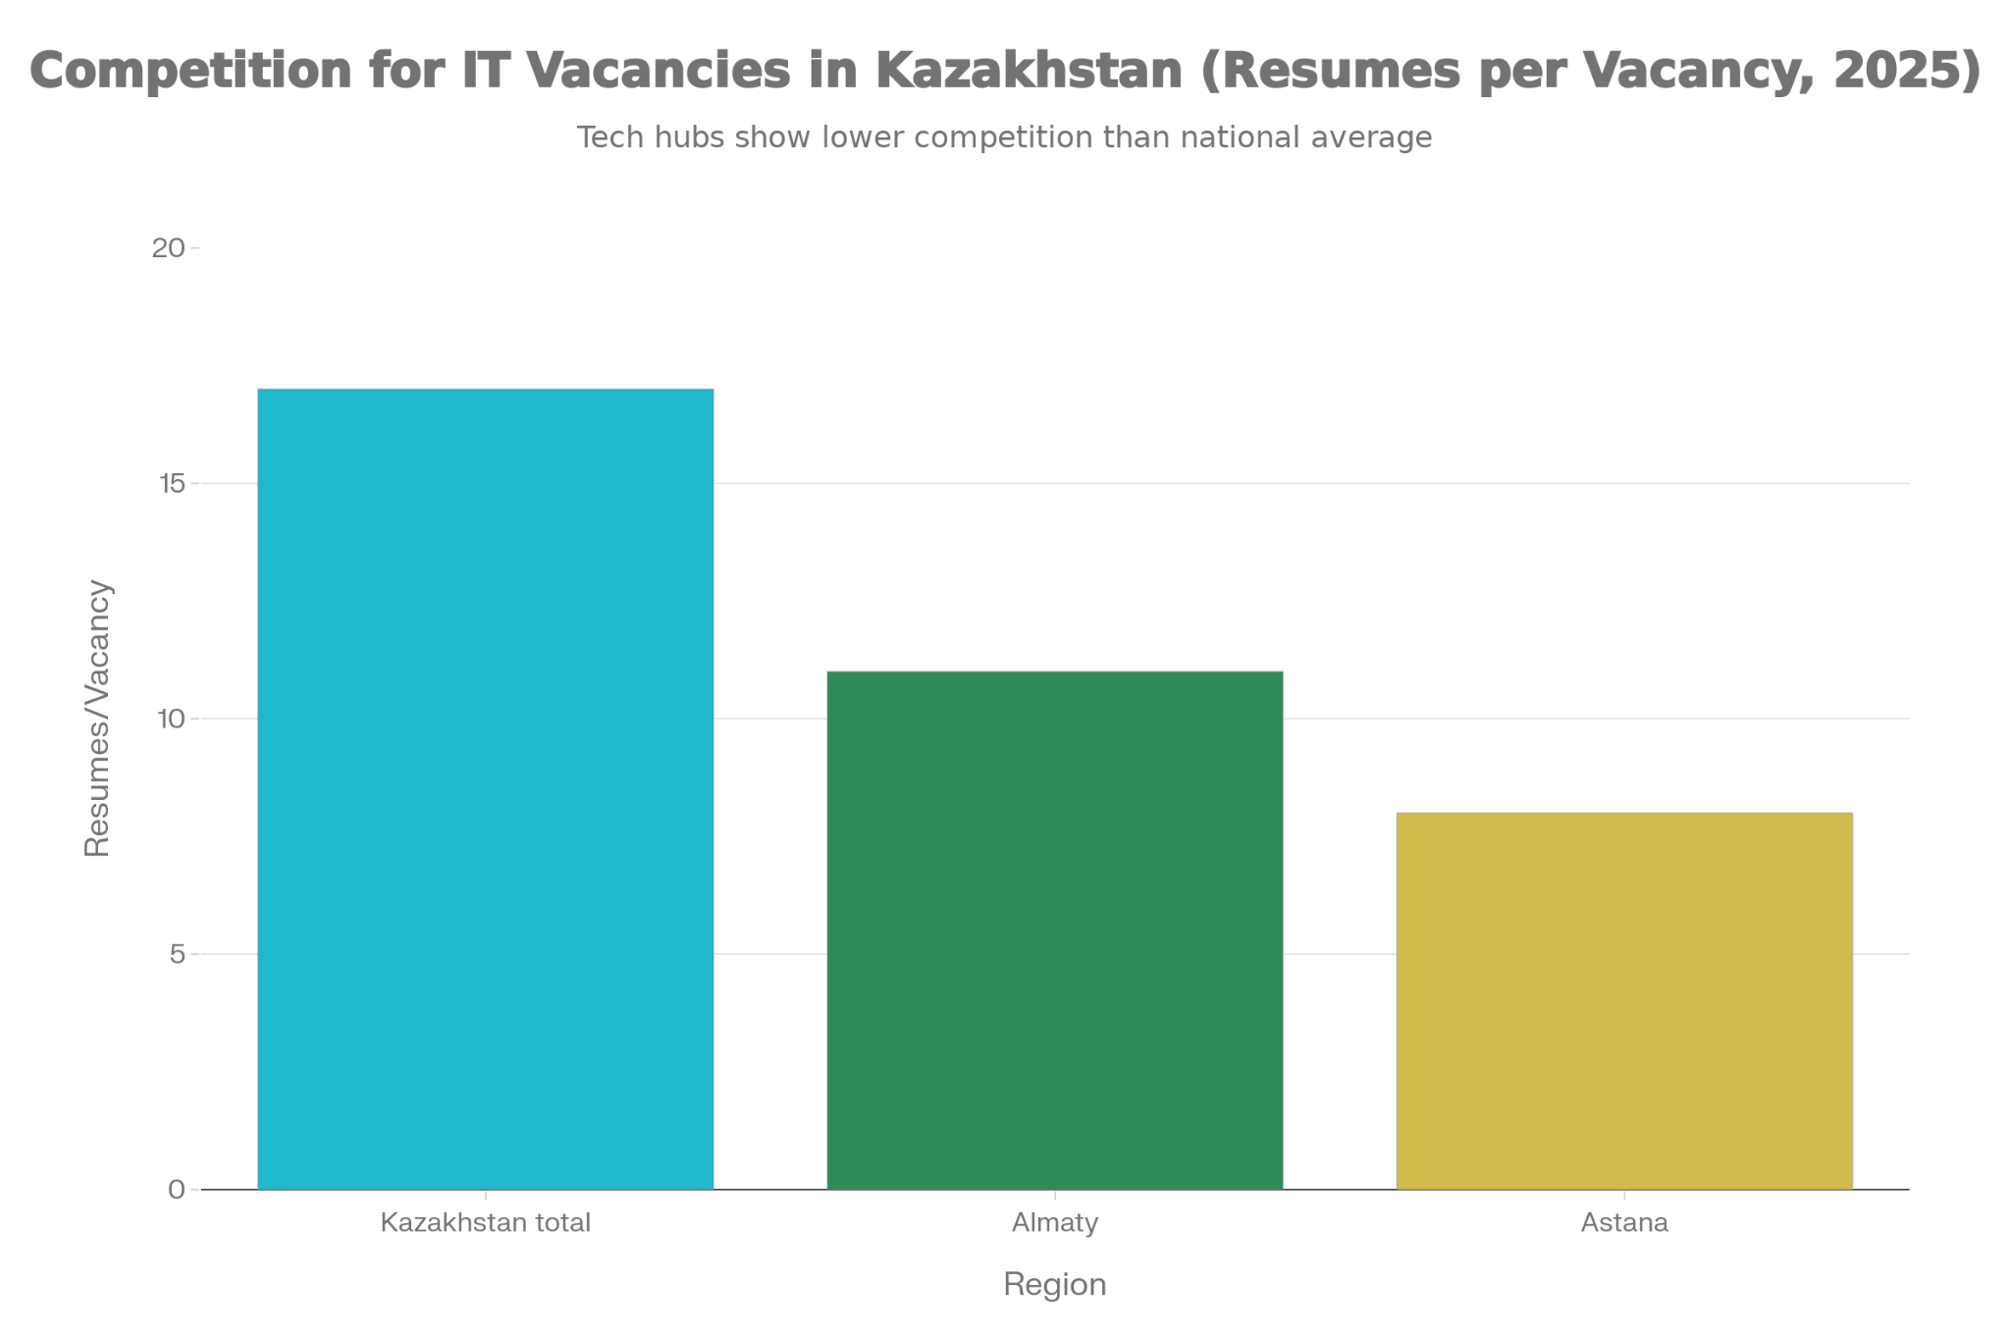
Figure 2. Competition for IT vacancies in Kazakhstan: resumes per vacancy nationwide and in Almaty and Astana, 2025 (based on electronic labor exchange data)

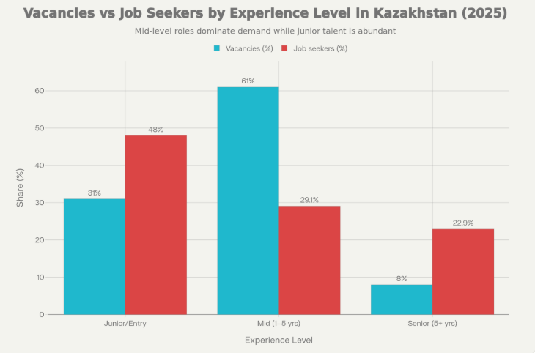
Figure 3. Experience mismatch between IT vacancies and job seekers in Kazakhstan, 2025 (based on Ranking.kz labor market analysis)

3.2 Customer relationships

3.2.1 Employers
Type of relationship
QualifyHub builds a combination of self‑service and personal relationships with employer clients:
- A self‑service web platform gives HR managers and engineering leads direct control over searching, filtering, and managing candidate profiles, as well as viewing analytics dashboards.
- For larger and enterprise clients, QualifyHub offers personal account management, onboarding support, and integration services to connect the platform with existing ATS or HR systems.
Trust, retention, and value
Trust is critical in HR decisions, especially in a market where salary levels and expectations are rising quickly. With IT salaries increasing by approximately 40–54% over the past few years and significantly exceeding the national average, employers must make fewer hiring mistakes and ensure that candidates’ skills match their compensation. QualifyHub supports this by:​
- Using human‑verified assessments run by experienced engineers and clear, standardized rubrics.
- Providing transparent score reports and notes that help employers understand the basis of each profile.
- Delivering analytics on time‑to‑hire, funnel conversion, and candidate performance, which help organizations continually refine their recruitment.
A long‑term relationship is expected: once QualifyHub is integrated into the employer’s process and historical data accumulates, the platform becomes part of strategic workforce planning, increasing retention and lifetime value.

3.2.2 Developers
Type of relationship
With developers, QualifyHub maintains a mix of self‑service and community‑based relationships:
- Self‑service scheduling and management of assessments, profile updates, and privacy settings.
- Community features such as webinars, coding challenges, and collaborations with local tech communities and universities.
Trust, retention, and value
Developers build trust in the platform when assessments are fair, transparent, and clearly explained. Detailed feedback helps them understand their strengths and weaknesses, and the ability to update their profile over time supports continuous professional growth. As they gain more experience or complete new courses (for example under Tech Orda), they can return for additional assessments and keep their profile up to date. This creates a long‑term relationship where QualifyHub acts as a career infrastructure rather than only a one‑time job board.​

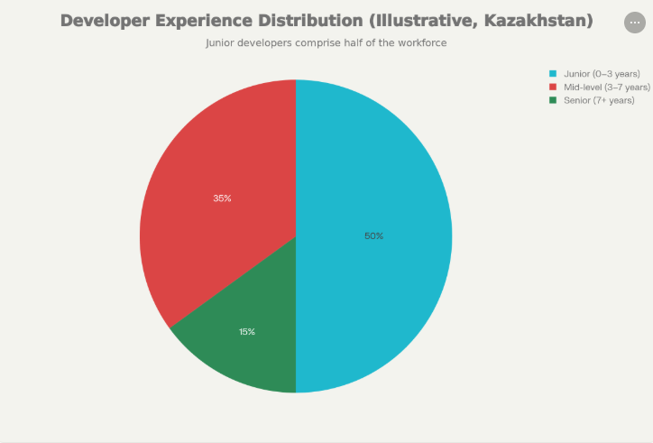
Figure 4. Illustrative distribution of developers by experience level in Kazakhstan, aligned with studies showing nearly half of IT job seekers are entry-level

4. Quantitative market analysis
The assignment requires at least 3–5 statistical indicators, an explanation of what each proves, and clear sources. QualifyHub’s market analysis is grounded in the following six key statistics:
- Number of IT companies and employment
  - 18,683 IT companies and approximately 187,000 IT workers in Kazakhstan by end‑2024.​
  - This shows a large and expanding base of potential employer clients and candidates, indicating that the market can support a specialized recruitment platform.
- Growth of IT salaries and demand
  - The average monthly salary of IT specialists increased by 54% over three years, reaching 673,000 tenge in 2024, while some programming and consulting salaries rose up to 2.5 times by mid‑2025 and significantly exceeded the national average.​
  - This demonstrates strong demand for skilled IT professionals and high stakes in hiring decisions, reinforcing the need for high‑quality assessment tools.
- Resumes per IT vacancy (national)
  - About 9,700 IT and telecom resumes vs 580 vacancies on the national electronic labor exchange equate to nearly 17 candidates per vacancy.​
  - This proves that employers face heavy screening loads, while individual candidates face intense competition, both of which create pain points that QualifyHub aims to relieve.
- Regional competition example
  - Regional breakdowns show 1,500 candidates for 133 roles in Almaty (≈11 per vacancy), 1,000 candidates for 124 roles in Astana (≈8 per vacancy), and 655 candidates for 4 roles in Mangystau (≈164 per vacancy).​
  - This demonstrates that some local markets are extremely congested, making it very challenging for HR teams to process applications efficiently and for developers to signal their quality.
- Experience mismatch between vacancies and candidates
  - 61% of IT vacancies require 1–5 years of experience, but 48% of job seekers are entry‑level and only a portion are mid‑level, with about 22.9% being senior.​
  - This reveals a structural mismatch between what employers seek and what the candidate pool offers, particularly at the junior level, emphasizing the value of assessment‑based signaling.
- Human capital development programs
  - National initiatives like Tech Orda aim to train around 20,000 IT specialists by 2025 and have already supported private IT schools that trained over 16,000 people.​
  - This indicates that the pipeline of junior and early‑career developers will continue to grow, further increasing the need for tools that help employers identify strong candidates and help juniors stand out.
Together, these statistics prove that Kazakhstan’s IT market is large, fast‑growing, and characterized by high competition and skill mismatches. QualifyHub’s value proposition—centralized human‑verified assessments, reusable profiles, and analytics—directly targets these quantified pain points.

5. Step 3 – Value Proposition Canvas (QualifyHub)
The Value Proposition Canvas summarizes how QualifyHub aligns its products and services with the jobs, pains, and gains of its main customers. The canvas focuses on employers as the primary customer profile, with developers as a secondary profile.

5.1 Customer profile – Employers
- Customer Jobs
  - Hire competent developers quickly to support product roadmaps and digital projects.
  - Reduce internal time spent on screening, test design, and technical interviews.
  - Minimize the risk of poor hiring decisions that can become costly in a high‑salary environment.​
- Pains
  - Too many resumes and too much noise: up to 17 candidates per vacancy nationally and even higher ratios in some regions.​
  - Difficulty verifying real skills, especially in a market with many juniors and self‑taught candidates.
  - Engineers spending large amounts of time on interviews instead of building products, which slows innovation.
- Gains
  - Access to a pre‑vetted pool of developers with transparent skill data.
  - Shorter hiring cycles and fewer interviews per hire.
  - Higher quality matches and reduced uncertainty about new hires.

5.2 Value map – For Employers
- Products & Services
  - QualifyHub platform with searchable Verified Talent Profiles.
  - Expert‑led technical assessments and standardized scoring rubrics.
  - Dashboards and analytics (time‑to‑hire, pass rates, funnel metrics).
  - Optional ATS integrations and enterprise reporting.
- Pain Relievers
  - Centralized assessments eliminate the need for each company to design and repeat its own tests for every candidate.
  - Human‑verified profiles reduce uncertainty and highlight candidates who can perform, even if they lack long formal experience.
  - Analytics reveal which channels and profiles produce better hires, allowing HR to make data‑driven decisions.
- Gain Creators
  - Ready‑to‑interview candidates shorten recruitment cycles.
  - Improved employer brand among developers, who see the assessment process as fair and efficient.
  - Ability to scale hiring without proportionally increasing HR and engineering interview load.

5.3 Customer profile – Developers (secondary)
- Customer Jobs
  - Obtain good technical positions in IT, fintech, or startups.
  - Prove skills to employers beyond just CVs and certificates.
  - Reduce stress and time spent on repeating similar tests for each company.
- Pains
  - High competition per vacancy and difficulty standing out in a crowded market.​
  - Repetitive and inconsistent technical tests.
  - Little feedback from traditional recruitment processes.
- Gains
  - A recognized Verified Talent Profile that can be reused across multiple employers.
  - Better job matches and more efficient interviews focused on fit rather than basic screening.
  - Clear feedback that helps guide learning and career decisions.

5.4 Value map For Developers
- Products & Services
  - Baseline assessments and specialized tracks (backend, frontend, data, DevOps).
  - Profile management with GitHub and portfolio integration.
  - Community events, webinars, and optional coaching.
- Pain Relievers
  - One structured assessment that can be reused, rather than many similar tests.
  - Transparent scoring and feedback that clarify where they stand.
- Gain Creators
  - Increased visibility to quality employers on the platform.
  - Opportunities to improve and retake assessments as they upskill.

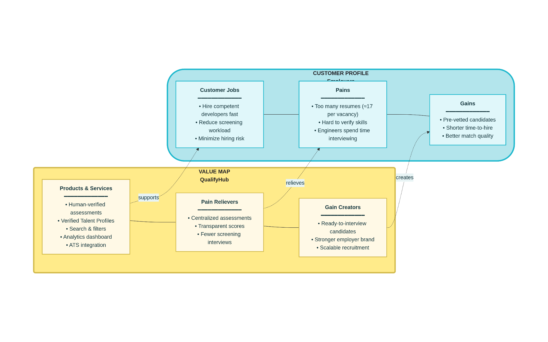
Figure 5. Value Proposition Canvas for QualifyHub and its primary customer segment (employers)

6. Conclusion
Kazakhstan’s IT sector is expanding rapidly in terms of company numbers, employment, and salary levels, but this growth has created serious tensions in the labor market. There are many more candidates than vacancies in IT and telecom, particularly in certain regions, and a significant mismatch between the experience levels employers demand and those that job seekers possess. At the same time, national initiatives like Tech Orda are adding thousands of new developers to the talent pool, further increasing competition and the need for better hiring mechanisms.​
QualifyHub responds to these challenges with a B2B‑centered business model supported by a strong B2C layer. Employers pay for access to human‑verified assessments, reusable Verified Talent Profiles, and analytics that reduce time‑to‑hire and hiring risk. Developers gain a fair, structured way to prove their capabilities and to stand out in a crowded market. The Value Proposition Canvas shows a tight fit between customer pains and the platform’s pain relievers, as well as between desired gains and the gain creators QualifyHub offers. This alignment, supported by quantitative evidence from Kazakhstan’s IT labor market, suggests that QualifyHub has a credible and scalable opportunity as a specialized HR tech platform.

References
Astana Times. (2024, December 11). Astana Hub drives growth in Kazakhstan’s IT sector, with revenues surging to 2.3 billion. The Astana Times. https://astanatimes.com/2024/12/astana-hub-drives-growth-in-kazakhstans-it-sector-with-revenues-surging-to-2-3-billion/
PrimeMinister.kz. (2025, January 20). Export of IT services in Kazakhstan exceeded $470 mln. Government of the Republic of Kazakhstan. https://primeminister.kz/en/news/export-of-it-services-in-kazakhstan-exceeded-470-mln-29593
Ranking.kz, & Times of Central Asia. (2025, September 25). Kazakhstan’s IT market: Post‑pandemic growth, skills gap, and 17 resumes per vacancy. The Times of Central Asia. https://timesca.com/kazakhstans-it-market-post-pandemic-growth-skills-gap-and-17-resumes-per-vacancy/
TAdviser. (2025, March 12). IT market of Kazakhstan. TAdviser. https://tadviser.com/index.php/Article:IT_market_of_Kazakhstan
The Strategyzer AG. (n.d.). Value proposition canvas. Strategyzer. https://www.strategyzer.com/canvas/value-proposition-canvas

